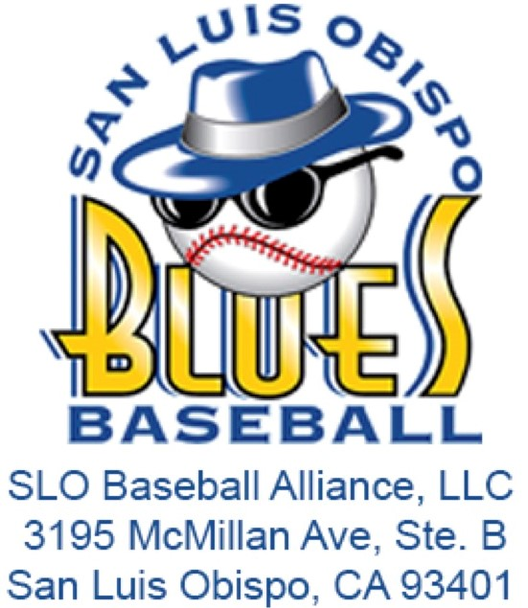**Job Description: Athletic Training Intern**

**Organization**: San Luis Blues / SLO Baseball Alliance, LLC  
**Supervisor**: Assistant General Manager, Certified Athletic Trainer  
**Term of Employment**: May 15, 2025 – August 15, 2025  
**Compensation**: $300 Stipend

# **Internship Overview:**

The Athletic Training Intern will gain hands-on experience in the field of athletic injury care, including injury prevention, first aid, rehabilitation, injury evaluation and recognition, and the organization and administration of athletic training services. The internship is designed to provide practical learning opportunities under the direct supervision of a Certified Athletic Trainer.

# **Key Responsibilities:**

* **Stadium Operations**:
  + Attend and assist with stadium move-in and move-out processes (Dates TBD).
  + Complete the setup and breakdown of both dugouts before and after each game.
  + Ensure that coolers and water bottles are cleaned and sanitized from previous use.
  + Fill water jugs with ice and water, and provide cups and/or water bottles for athletes.
  + Prepare a cooler with injury ice for use during games.
  + Set up athletic training equipment near the home dugout, including treatment tables, medical kits, and other necessary supplies.
* **Pre-Game Preparation**:
  + Assist with pre-game treatments such as taping, stretching, and manual therapies under the supervision of the Certified Athletic Trainer.
  + Provide basic wound care to athletes as needed.
* **Injury Management**:
  + Assist with rehabilitation exercises for injured athletes.
  + Participate in emergency response situations, providing support as directed by the Certified Athletic Trainer.
* **Post-Game and Event Duties**:
  + Assist in the cleanup of the stadium following home events.
  + Ensure all athletic training equipment is properly stored and maintained.
* **Healthcare Privacy**:
  + Maintain strict confidentiality and privacy regarding all athlete healthcare information and treatments.
* **Analysis and Reporting**:
  + Perform a brief season-end analysis of the 2025 operational plan, including assessments of successes, failures, and suggestions for improvement.
* **Additional Duties**:
  + Undertake other responsibilities as assigned by Blues Management.

# **Qualifications:**

* Must be currently enrolled in an athletic training or related program.
* Basic knowledge of athletic training techniques, injury prevention, and first aid.
* Strong organizational and communication skills.
* Ability to work collaboratively with the team and maintain a positive attitude.
* Willingness to learn and take direction from experienced professionals.
* Commitment to maintaining healthcare privacy and confidentiality.

# **Learning Objectives:**

* Gain practical experience in athletic injury care and rehabilitation.
* Develop skills in the setup and administration of athletic training operations.
* Learn to provide basic wound care and assist in emergency responses.
* Enhance understanding of injury prevention, evaluation, and treatment techniques.
* Experience the day-to-day responsibilities of an athletic trainer within a sports organization.

# **Application Process:**

Interested candidates should submit a resume and cover letter outlining their qualifications and interest in the position to the [SLO Blues Internship Application](https://forms.gle/Drxv2iUd4kMV4xeQ6) by May 1.