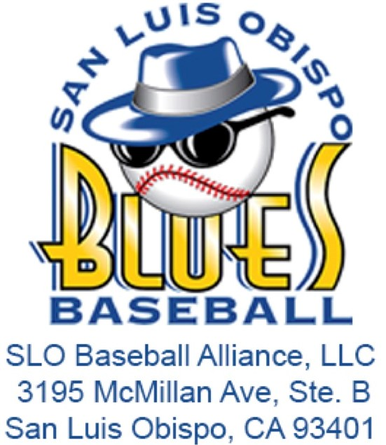**Job Description: Promotional Team Intern**

**Organization**: San Luis Blues / SLO Baseball Alliance, LLC  
**Preferred Majors**: Business, Recreation  
**Supervisor**: Assistant General Manager  
**Term of Employment**: May 10, 2025 – August 10, 2025  
**Compensation**: $300 Stipend

# **Internship Summary:**

The Promotional Team Intern will be integral to the execution of gameday operations for the San Luis Blues baseball season. This team serves as the front-line staff, responsible for managing all aspects of a Blues game day event. Interns in this role will gain hands-on experience in sports marketing and operations, contributing to the development of a positive image within the San Luis Obispo community.

# **Key Responsibilities:**

* **Game Day Promotions**:
  + Assist in the planning and execution of promotional activities and gameday elements throughout the season.
  + Execute all on-field and in-game promotions, ensuring a smooth and engaging experience for fans.
* **Stadium Operations**:
  + Assist in the setup, breakdown, and cleanup of the Blues facility at all home games.
  + Rotate through and gain experience in various gameday operational stations, including:
    - Marketing/Information Table
    - Ticketing
    - Beer & Wine Venue
    - Program Cart
    - Hospitality Tent
    - Scoreboard Operation
    - Mascot Support
* **End-of-Season Duties**:
  + Participate in the move-in and move-out processes at the start and end of the season (dates TBD).
  + Conduct a brief season-end analysis of the 2025 operational plan, identifying successes, failures, and areas for improvement.
* **Additional Duties**:
  + Perform other tasks as assigned by Blues Management to support the overall success of the team’s promotional efforts.

# **Qualifications:**

* Currently enrolled in a degree program, preferably in Business, Recreation, or a related field.
* Strong interest in sports marketing and event management.
* Excellent communication and organizational skills.
* Ability to work collaboratively in a team-oriented environment.
* Flexibility to work evenings, weekends, and holidays as needed.
* Positive attitude, strong work ethic, and a passion for creating memorable fan experiences.

# **Learning Objectives:**

* Gain practical experience in executing sports marketing and promotional strategies.
* Develop skills in event management, including the setup and operation of gameday activities.
* Enhance understanding of fan engagement and community relations in a sports setting.
* Learn to analyze and evaluate the effectiveness of promotional activities.

# **Application Process:**

Interested candidates should submit a resume and cover letter outlining their qualifications and interest in the position to the [SLO Blues Internship Application](https://forms.gle/Drxv2iUd4kMV4xeQ6) by May 1.