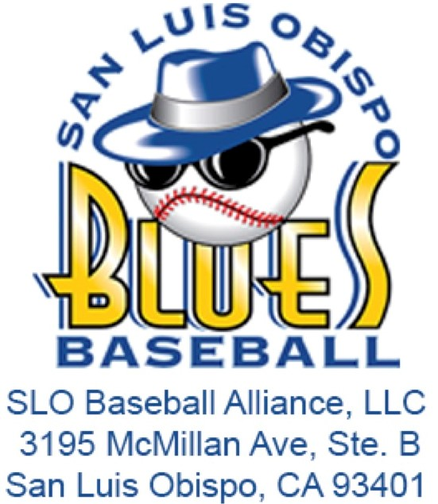**Job Description: Director of Press Box Operations**

**Organization**: San Luis Blues / SLO Baseball Alliance, LLC  
**Preferred Majors**: Business, Recreation, Communication  
**Supervisor**: Assistant General Manager, General Manager  
**Term of Employment**: Summer 2025 (May 15th – August 15th)  
**Compensation**: $500.00

# **Internship Summary:**

The Director of Press Box Operations Intern is responsible for planning, executing, and maintaining all press box operations during the 2025 SLO Blues season. This role involves managing various aspects within the press box, including radio broadcasts, statistics, public address announcements, music, scoreboard operations, social media, photography, and special effects. The intern will ensure the press box runs smoothly and contributes to creating an optimal game day atmosphere, enhancing the overall fan experience through innovative and dynamic special effects.

# **Responsibilities:**

* **Press Box Setup and Management**:
  + Prior knowledge of baseball is required.
  + Complete the setup of the entire press box, including PA system, mixer, wireless microphones, music, scoreboard, special effects equipment, and additional tables and chairs.
  + Assist in the setup and breakdown of the Blues Nation suite and balconies.
* **Game Day Operations**:
  + Deliver water and statistical updates to all necessary individuals present for the game.
  + Direct all press box operations after the first pitch, ensuring smooth game day execution.
  + Enhance the game day atmosphere by utilizing sound bytes, music, and special effects in collaboration with the Public Address Announcer.
  + Implement and manage special effects during key moments in the game, such as player introductions, home runs, and crowd engagement activities.
  + Assist the rotating scorekeeper with any scoreboard issues promptly.
  + Provide support to the Director of Game Day Operations and Marketing Coordinators as needed.
* **Special Effects Management**:
  + Operate and maintain special effects equipment, such as fog machines, light effects, and other audiovisual elements, ensuring they are used effectively and safely during games.
  + Coordinate with the marketing and game day operations teams to integrate special effects into promotional events and fan engagement activities.
* **Press Box Breakdown and Clean-Up**:
  + Complete the breakdown and storage of the press box, special effects equipment, and Blues Nation after each game or event.
  + Thoroughly clean the press box, including cleaning equipment, vacuuming, and disposing of trash.
* **Season-End Analysis**:
  + Perform a brief season-end analysis of the 2025 operational plan, identifying successes, failures, and suggestions for future improvements, with a focus on special effects and their impact on fan engagement.
* **Additional Duties**:
  + Execute any other duties as assigned by Blues Management to support the overall success of the press box operations, special effects, and the organization.

# **Qualifications:**

* Currently enrolled in a degree program, preferably in Business, Recreation, Communication, or a related field.
* Strong organizational and communication skills.
* Ability to work independently and as part of a team in a fast-paced environment.
* Experience in event management, sports operations, or special effects is highly desirable.
* Technical proficiency with audiovisual and special effects equipment.
* Willingness to work evenings, weekends, and holidays as required during the baseball season.
* A passion for baseball and a commitment to providing a top-notch game day experience.

# **Learning Objectives:**

* Gain hands-on experience in managing press box operations and special effects within a sports organization.
* Develop skills in communication, event coordination, technical operations, and special effects management.
* Learn to create and maintain a professional and dynamic game day atmosphere.
* Enhance understanding of media relations, in-game entertainment, and fan engagement through special effects.

# **Application Process:**

Interested candidates should submit a resume and cover letter outlining their qualifications and interest in the position to the [SLO Blues Internship Application](https://forms.gle/Drxv2iUd4kMV4xeQ6) by May 1.