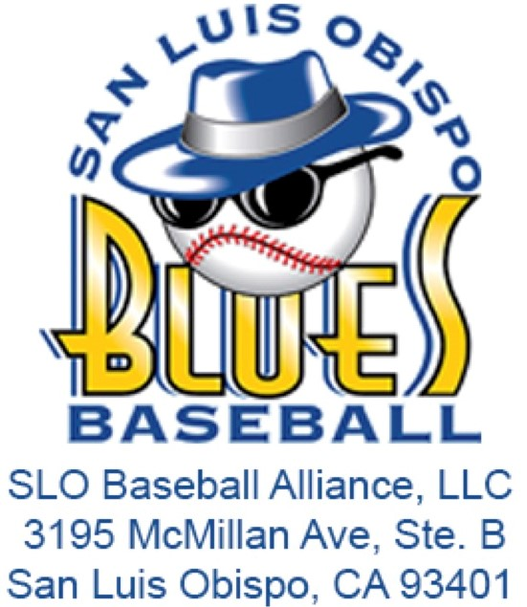**Job Description: Director of Merchandise**

**Organization**: San Luis Blues / SLO Baseball Alliance, LLC  
**Preferred Majors**: Recreation, Business, Marketing  
**Supervisor**: Assistant General Manager  
**Time Frame**: Pre-Season (TBD) to August 15  
**Compensation**: Stipend - $500, plus Commission - 2.75% of game day merchandise revenue

# **Internship Summary:**

The Director of Merchandise Intern will be responsible for the design, procurement, marketing, and distribution of merchandise during the San Luis Blues Baseball season. This role requires a combination of creativity, business acumen, and organizational skills to ensure that merchandise operations are successful and that customer and supplier relationships are effectively maintained. The ideal candidate will be motivated, professional, and eager to learn in a dynamic environment.

# **Responsibilities:**

* **Marketing & Sales**:
  + Develop and execute marketing campaigns aimed at increasing merchandise sales and reaching large audiences.
  + Design a merchandise booth that enhances the professional image of the Blues and streamlines setup and cleanup procedures.
  + Update, price, plan, order, and arrange merchandise for display at all Blues home games and on the team website.
* **Customer & Supplier Relations**:
  + Respond to all merchandise inquiries via phone, internet, or in-person interactions, ensuring a high level of customer service.
  + Fulfill all merchandise orders at the ballpark.
  + Maintain strong relationships with suppliers and ensure timely procurement of merchandise.
* **Inventory Management**:
  + Control inventory, track sales, and maintain accurate records of stock.
  + Receive shipments, verify invoices, and ensure that all merchandise is accurately accounted for.
  + Implement and enforce departmental policies related to merchandise operations.
* **Operations & Reporting**:
  + Assist in developing, implementing, and enforcing policies related to merchandise operations.
  + Prepare a summary report for Blues Management at the end of the season, detailing sales performance, inventory management, and suggestions for improvement.
  + Handle any additional duties as assigned by Blues Management.

# **Qualifications:**

* Currently pursuing a degree in Recreation, Business, Marketing, or a related field.
* Strong organizational and communication skills.
* Creative and strategic thinker with the ability to design and execute marketing campaigns.
* Ability to manage inventory, fulfill orders, and maintain accurate records.
* Professionalism and initiative, with the ability to work independently and as part of a team.
* Experience in retail, sales, or customer service is a plus.
* Willingness to work evenings, weekends, and holidays as required during the baseball season.
* A passion for sports and a commitment to enhancing the San Luis Blues brand.

# **Learning Objectives:**

* Gain hands-on experience in merchandise management, including design, procurement, marketing, and sales.
* Develop skills in inventory control, customer service, and supplier relationship management.
* Learn to create and implement marketing strategies that drive merchandise sales.
* Enhance understanding of retail operations within a sports organization.

# **Application Process:**

Interested candidates should submit a resume and cover letter outlining their qualifications and interest in the position to the [SLO Blues Internship Application](https://forms.gle/Drxv2iUd4kMV4xeQ6) by May 1.