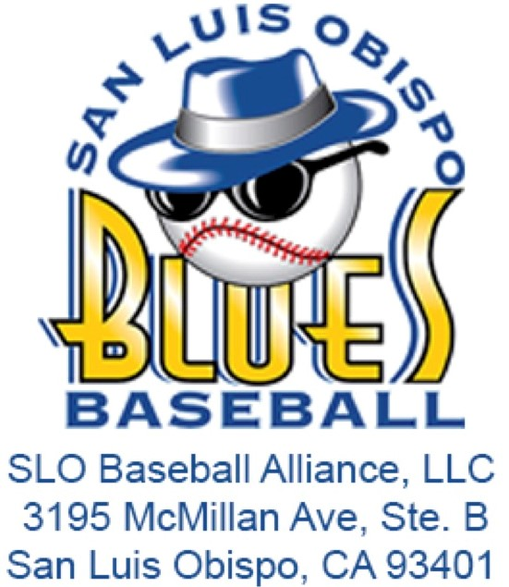**Job Description: Director of VIP & Corporate Events**

**Organization**: San Luis Blues / SLO Baseball Alliance, LLC  
**Direct Supervisor**: Assistant General Manager & General Manager  
**Term of Employment**: May 1, 2025 - August 15, 2025  
**Compensation**: $500 Stipend + Tips in VIP

# **Internship Summary:**

The Director of VIP & Corporate Events Intern is responsible for managing all aspects of VIP events during the 2025 San Luis Blues baseball season. This role is critical in ensuring that VIP groups, who are some of the organization’s largest stakeholders, experience top-tier service and hospitality. The intern will work closely with Blues Management to deliver flawless execution of these events, contributing to the organization’s positive image within the San Luis Obispo Community. This position requires an extroverted individual who is deeply invested in community engagement and service excellence.

# **Responsibilities:**

* **VIP Group Organization**:
  + Organize and maintain a detailed chart of VIP groups, including dates, requested drinks, food orders, and special requests.
  + Ensure all VIP events are meticulously planned and executed according to the group’s preferences and contractual agreements.
* **Event Management**:
  + Oversee and manage all VIP events, ensuring that guests receive professional and hospitable service throughout their experience.
  + Coordinate with Blues Management to understand and fulfill all aspects of VIP contracts, including requirements for beer, wine, food, and any special requests.
* **Inventory and Supplies Management**:
  + Manage all VIP inventory and supplies, including but not limited to beer/wine cups, soft drinks, water, alcoholic beverages, cleaning supplies, and wristbands.
  + Ensure the VIP section is fully stocked and prepared for each event.
* **Set-Up and Break-Down**:
  + Complete the set-up and break-down of the VIP section before and after each event.
  + Assist in the set-up and break-down of Blues Nation, ensuring all areas are prepared for game day operations.
* **Season-End Analysis**:
  + Perform a brief season-end analysis of the 2025 operational plan, highlighting successes, identifying failures, and offering suggestions for improvement.
* **Additional Duties**:
  + Execute any other duties as assigned by Blues Management to support the overall success of the organization.

# **Qualifications:**

* Currently enrolled in a degree program, preferably in Business, Hospitality, Event Management, or a related field.
* Strong organizational and communication skills.
* Ability to work independently and as part of a team.
* Experience in event management or customer service is highly desirable.
* Willingness to work evenings, weekends, and holidays as required during the baseball season.
* A positive attitude, professionalism, and a strong commitment to community engagement.

# **Learning Objectives:**

* Gain hands-on experience in managing VIP and corporate events.
* Develop skills in hospitality, event coordination, and customer service.
* Learn to manage inventory and supplies for large-scale events.
* Enhance understanding of community relations and stakeholder engagement within a sports organization.

# **Application Process:**

Interested candidates should submit a resume and cover letter outlining their qualifications and interest in the position to the [SLO Blues Internship Application](https://forms.gle/Drxv2iUd4kMV4xeQ6) by May 1.